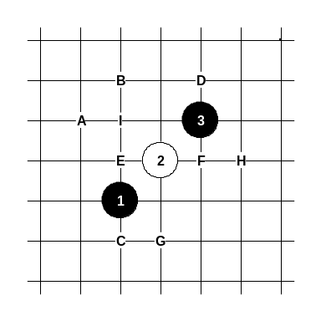
Opening Indirect 1
i1 長星
This opening was very popular over 15 years ago. Until now, the players still consider this opening to be very difficult. According to the theory, white has an advantage here. However, black attack can sometimes be really dangerous, and without good theoretical preparation the white player may easily lose the game. It is quite possible that after some years the i1 opening will be popular again as there are still so much undiscovered possibilities. You may wonder, how it is possible that i1 opening which was so popular in past, still has so much opportunities and undiscovered ways, why the players in the old times didn’t make a deep theory about i1. The reason is traditional playing – people at that time hesitated to discover new things, and most of the games (according to the database records) were played in the same style. For comparison, you can think of d11 opening – it has gone through a big theoretical re-evaluation. Sometimes the players feel a little bit afraid of playing i1 opening without preparation, so they try to lead the game into d3 opening with moves 4-E or 4-F. Sometimes I do so, too.
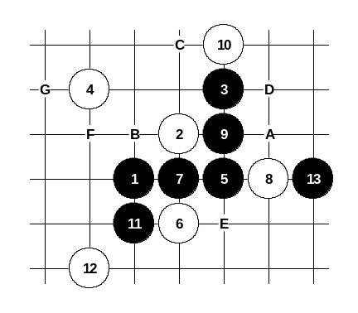

Diagram i1-1

A

We discuss every opening starting from unusual or seldom played 4th moves and ending with the most common moves. This 4th move is quite interesting. The previous renju books haven’t said anything certain about it. Even now, it is still hard to make any final conclusion about it. I will present the ways for black which I think are the most useful. The 5-5 is the strongest 5th move. It is quite easy to play here. The variant on the diagram i1-1 ends with black win. If 6-7 then 7-6, 8-A, 9-B. If 6-9 then 7-A, 8-6, 9-C, 10-13, 11-D. If 6-E then 7-6, 8-A, 9-F, 10-G, 11-H.

Diagram i1-2
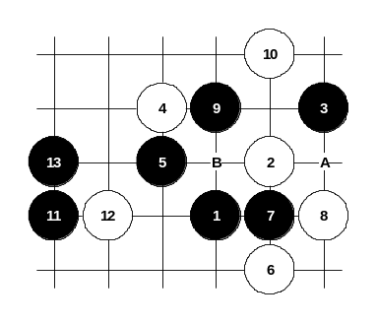
Another 5th move causes much more problems for black. In Japanese books, even moves 5-7 and 5-A have been mentioned, but they are all quite weak (5-A leads to d3 opening with moves 6-8, 7-9, 8-B, 9-7). The 5-5 is the best solution for alternative 5th move. Black gets a powerful attack as the space on the left side is sufficient for development.
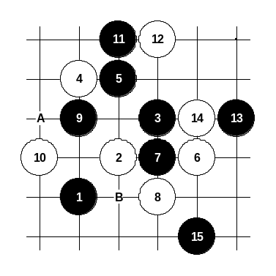

Diagram i1-3

B
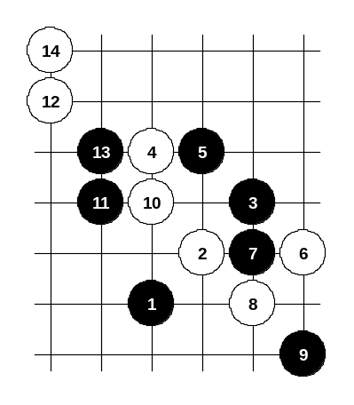
Here you can see the difference from the move 4-A. In case of 4-4 the space for black attack is much smaller, therefore the similar developing ideas do not work here. The main 5th move 5-6 is still doing well, but the alternative 5-5 has problems. Active developments like 11-14 or 11-12 do not bring any success. The shown variant is probably the best that the black can achieve here. Another possibility it to lead the game to d3 opening with 5-B, but there the position is even worse.

Diagram i1-4
As you can see, the passive style is not suitable for black. White can easily develop a dangerous attack. In this diagram, white wins despite the narrow space in upper side.

As a conclusion, this 4th move is as playable as the traditional 4-10.
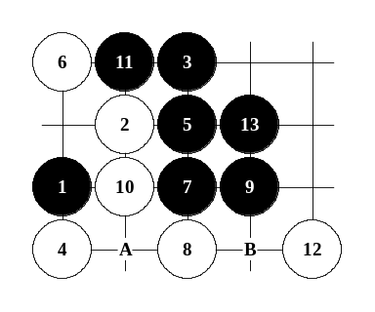

Diagram i1-5

C
Another 4th move. Here the black wins for sure. The main 5th move is very powerful.
If 6-7 then 7-6. If 6-A then 7-11, 8-6, 9-B.
Alternative 5th move is shown on the next diagram.
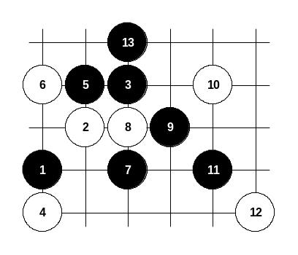

Diagram i1-6

This is the example of alternative 5th move. Other 8th or 10th moves lose fast, too.

D
The change of edge distance does not influence the black win in any way. Here the black wins exactly in the same way as in case of C:.

In this case, the game will turn into d3 opening. Please read from the d3 opening pages about these variants. The brief evaluation is: Both black and white are very equal there. It is very hard to prove clear advantage for either side.

E

The edge closeness influences the d3-variants a lot. Surprisingly there has not been much research about it. Perhaps it is because the people consider the standard variant (I:) as the best option for white, therefore they have no need for leading the game into d3 opening. Those who want to try something new, they may go through the d3 opening theory and try those variants using this F: starting position, and try to find the situations where the board edge influences the result of the attack for either side.

F
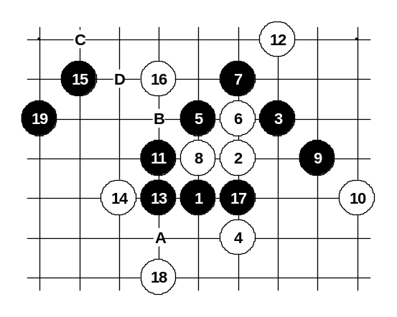

Diagram i1-7
This 4th move actually leads to i5 opening variants. I will discuss these variants under i1 opening though. So, from i5 opening pages you will be linked here.

G
Black has three possible 5th moves: 5-5, 5-6, 5-17. Move 5-5 is the best. Black gets very promising position and wins in most cases. The 7-7 is better than 7-17. Move 15-15 is a key move for black’s development, whereas move 17-17 is a key move for neutralizing white’s possible counter-attack.
If 18-A then 19-19.
If 18-B then 19-C.
If 16-B then 17-D.
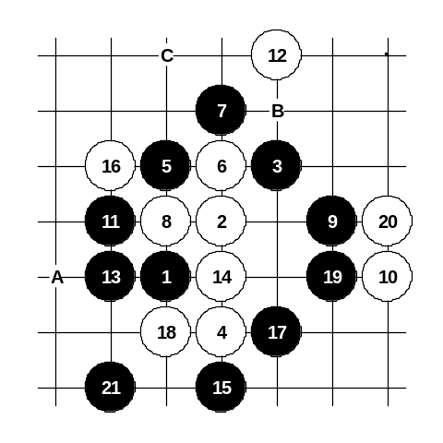

Diagram i1-8
Another 14th move. Active defense doesn’t bring any success for white. Black easily surrounds white stones and wins. Perhaps some other 16th move would be better, but black is still too powerful and will most likely win.
If 12-A, then 13-12, 15-B.
If 10-C then 11-14.

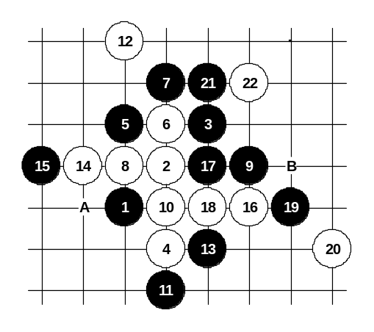

Diagram i1-9
This diagram shows the best that white can achieve in case of this 5th move. Moves 10 and 12 create an activity for white. Black has to be very careful now, as the move 13-13 is the only possible one here. Move 15-15 is also forced. If 15-17 then 16-21 and white wins. After 15-15 white must continue passively 16-16, because if 16-A then 17-21 or if 16-21 then 17-A, and black would win.
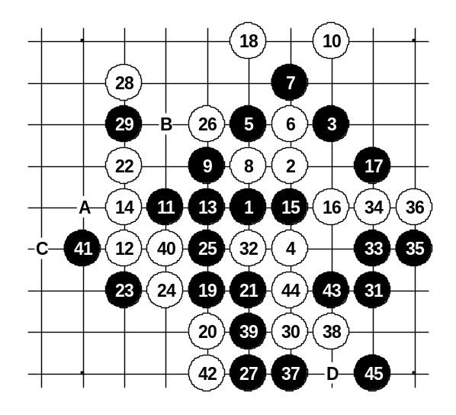
After the 22nd move black has so many good choices for attacking all over the board. Any other 22nd move makes black’s task even easier. If 14-17 then 15-16, 16-B, 17-14. If 14-16 then 15-17, 16-21, 17-A and white is unable to block all black’s threats.

Diagram i1-10
Those who favor straight style, they may try another 9th move as shown on this diagram. Move 25-25 is necessary, otherwise black loses (white would win by straight attack 28,A,B,C,41). The idea of 31st move is to take a powerful point as well as preparing to force white stone to point 44 which would make point 32 as legal 4x3.
If 20-25 then 21-32 and easy win. After 14-15 the position becomes similar to the diagram i1-8, black wins there.
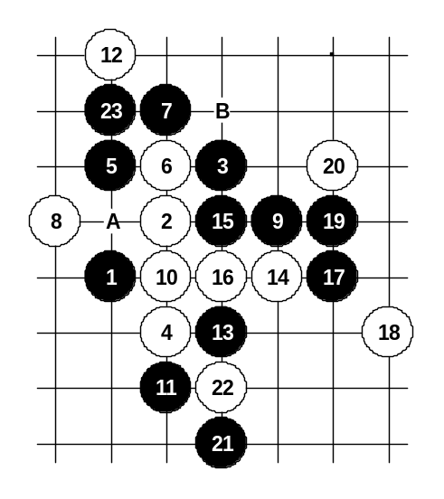

Diagram i1-11
Black gets very powerful position and winning here is not difficult at all. On the diagram, the moves 19, 21, 23 are just one example of winning development. You can try to find your own ways of development as well.
If 14-A then look at the diagram i1-9.
If 10-12 or 10-17 then 11-10.
If 12-17 then 13-B.
If 8-9 then 9-8 and black has a straight win.

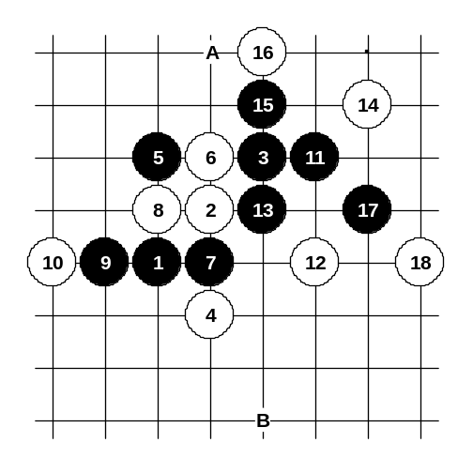

Diagram i1-12

Here you can see another 7th move. White has to make several correct moves (especially 12-12), and as a result, black attack will fail. If 18-A (a mistake) then 19-B and black wins.
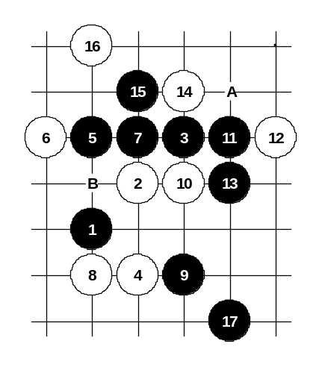
You can learn about this 7th move, but I do not recommend to play it - the outcome of this variant is too bad for black.

Diagram i1-13
Besides the traditional 6th move (6-7), white has another 6th move (6-6) which is also very interesting. Black can still win, starting with careful development from move 7-7. If 14-A then 15-16, 17-B, 19-14 and win in few moves. Any other 14th move loses, too. If 10-11 then 11-10 and straight win.
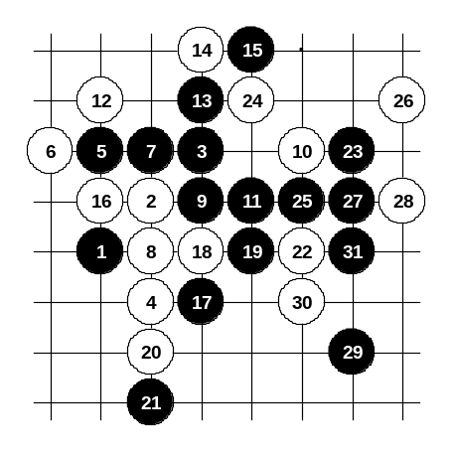

Diagram i1-14

Another 8th move. White tries to provoke black to straight attack. Black has to be careful and avoid straight attack in moves 9 and 11. From move 13-13 black begins straight winning attack. If 20-22 then black has VCF. Any other 20th move loses fast, too.

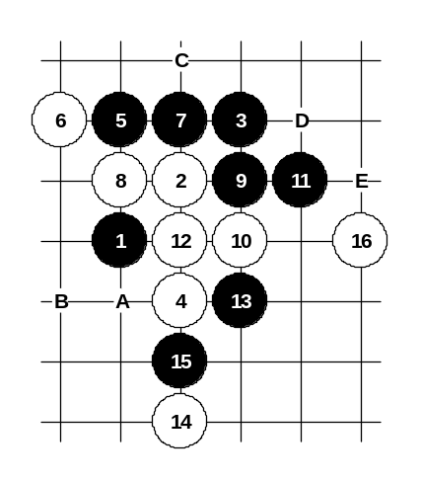

Diagram i1-15
This 8th move is probably the strongest. Black does not have straight win here. However, in order to defend, white must play actively which actually makes white structure very helpless - black can easily continue developing in upper area. Another way to play is 10-13, 11-12, 12-A, 13-B, 14-10, 15-11, 16-C, but then black wins by 17-D, 19-E.

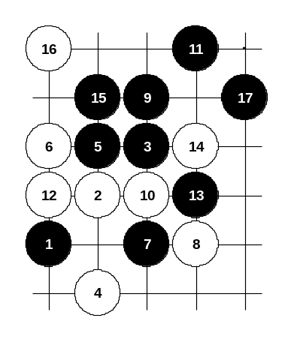
This is the alternative 5th move. Black gets very good attack here, too. However, this 5th move is much more difficult to learn, as in many variants the black development is not easy.

Diagram i1-16
White has only one 6th move here that is worth to discuss (6-6), other 6th moves lose very fast.
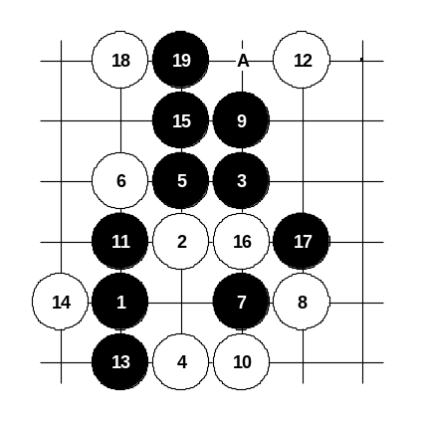
In following diagrams different 8th moves are discussed. This 8th move is quite active, but weak.

Diagram i1-17
This 10th move is really interesting. Stones 4, 8 and 10 work so effectively together. Black is forced to give up some of the attacking power for defensive purposes (moves 11 and 13). However, black still gets powerful position after 15-15. If 16-A then 17-19.

Diagram i1-18
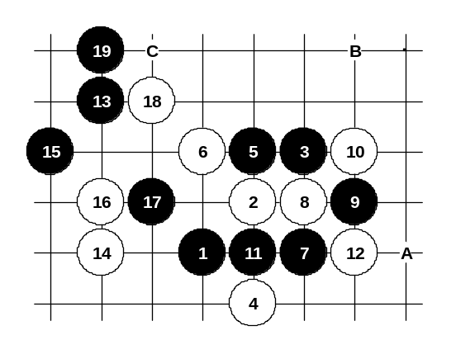
Another 8th move.
Move 10-10 is the best. In old books, the black development was quite poor. The diagram here (from “Click of Stones” book) seems to be the best that black can achieve after this 10-10. If 16-C then 17-16. If 10-A then 11-B.
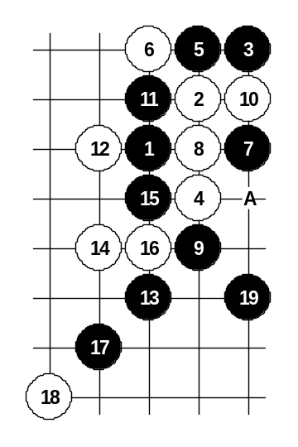

Diagram i1-19

In the old times, this 8th move was considered to be very good, the traditional moves were 13-14 and 14-13 and the outcome was equality. But modern theory suggests the attack shown in diagram. Black gets very powerful attack here. As you may have recognized, the same pattern comes also from d3 opening (with 90 degrees rotation).
If 14-A then 15-14.

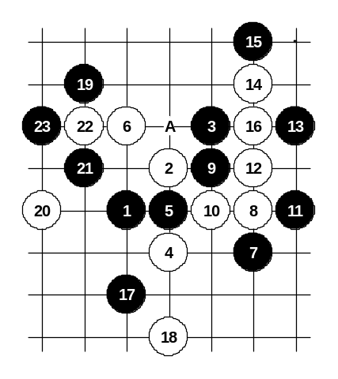
This 5th move is not as good as 5-6 or 5-A, but it still gives black satisfying advantage. Black can practice positional style here. The skill of global attack and ability to see the “whole board” becomes more important. The idea of 7th move – to control white’s activity (line 6_2) without playing primitively 7-10 (move 7-10 is really bad because of absence of black’s straight win). The outcome of the variant is very satisfying for black.

Diagram i1-20
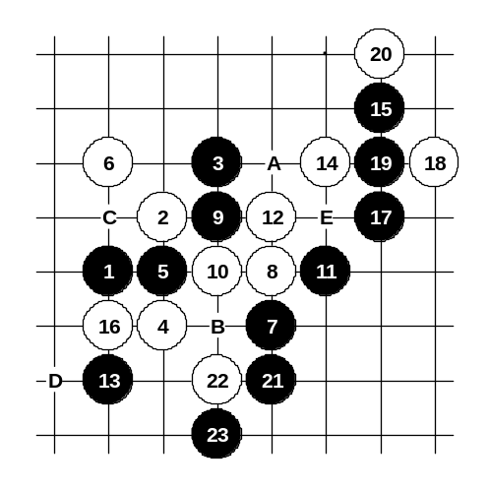

Diagram i1-21
Black changes the 13th move but the concept of the positional development is same.
If 14-16 then 15-14, 16-E, 17-17, 18-18, 19-19.
If 12-A then 13-13, 14-22, 15-B, 16-C, 17-D.

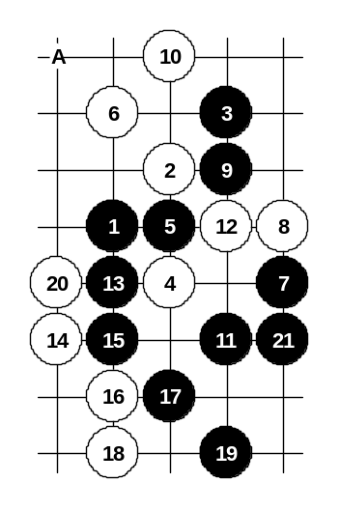

This is how black wins in case of gambling 10th move. Japanese theory offers 11-A but the outcome is quite poor for black there.

Diagram i1-22

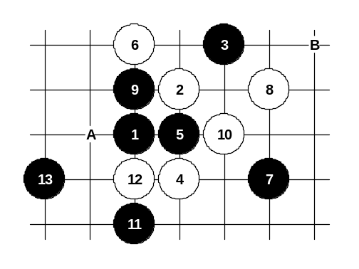

Diagram i1-23

White tries to change the 8th move, but black can still keep the advantage and the attack is very promising.
If 10-A then 11-B.
If 6-8 then 7-9, 8-10, 9-11, 10-12, 11-7.

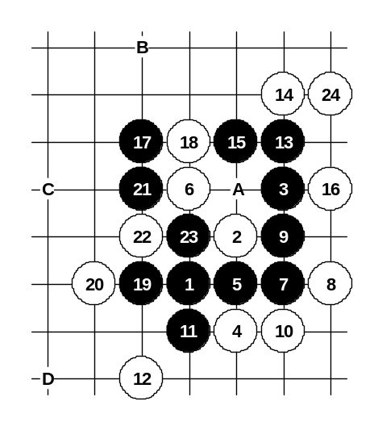
This diagram shows well why such straight 7th move is bad. Black has an attack, but finally it fails after correct 24th move (24-24). As a result, black stones will be surrounded by white stones and black will lose fast.

Diagram i1-24
If white plays 24-A then black wins after 25-B, 27-C.
Move 10-10 is necessary because after 10-13 black’s attack is very dangerous: 11-12, 12-11, 13-10, 15-D.
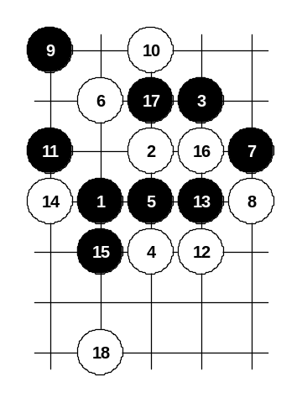

Diagram i1-25
One more example of 7th move. In case of careful white moves, white easily takes the control and the advantage by 18th move. I do not recommend to play such 7th move.
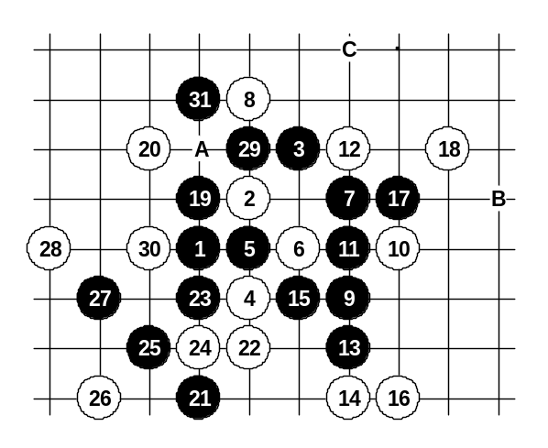

Diagram i1-26
Another 6th move. Here the black play is much easier. There are several possible 7th moves – 7-7, 7-A, 7-9. Move 7-7 is the strongest. In this diagram, black begins straight attack from move 11 that ends with black win. If 18-22 then 19-B, 21-19, 23-31, 25-29, 27-C.
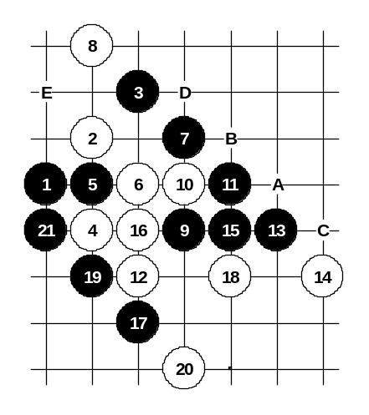

Diagram i1-27
Another 10th move. Black’s moves 13, 15, 17 are classical development in similar patterns. Move 18-18 is the best, but after beautiful 19-19 white position becomes hopeless. If 20-21 then 21-A. If 18-B then 19-19. If 16-C then 17-B and straight win. If 8-9 or 8-D or 8-11 then 9-E.
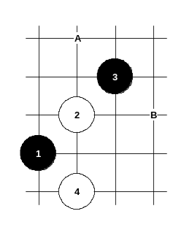

Diagram i1-28
There are two more interesting 5th moves (5-A and 5-B) which have not been properly analyzed yet. Therefore we cannot provide any certain opinion here.

